CSA0315 – DATA STRUCTURES

CO3 – AT3
TREE TRAVERSAL CHALLENGES

By:
G MANISH

CO3- AT3- Tree Traversal Challenges
Write the traversal sequences for following trees

Question No :1

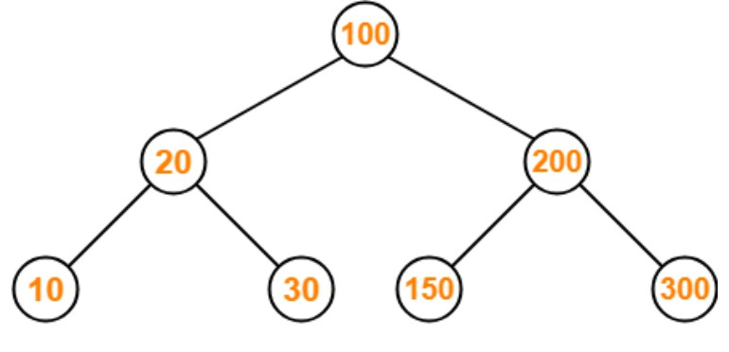
ANS:
INORDER: 10,20,30,100,150,200,300
PREORDER: 100,20,10,30,200,150,300
POSTORDER: 10,30,20,150,300,200,100

Question No : 2
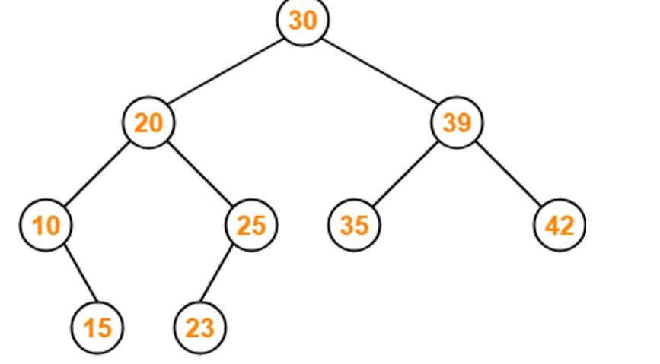
ANS:
INORDER: 10,15,20,23,25,30,35,39,42
PREORDER: 30,20,10,15,25,23,39,35,42
POSTORDER: 15,10,23,25,20,35,42,39,30

Question No : 3
Assume the digits 7, 5, 1, 8, 3, 6, 0, 9, 4, 2 are added in that sequence into a binary search tree that is initially empty. The binary search tree follows the standard natural number ordering. What is the resulting tree's traversal sequence?

ANS:
INORDER: 0,1,2,3,4,5,6,7,8,9
PREORDER: 7,5,1,0,3,2,4,6,8,9
POSTORDER: 0,2,4,3,1,6,5,9,8,7
Question No : 5
1
/ \
2 3
/ \ \
4 5 6
/
7
ANS:
INORDER: 4,2,7,5,1,3,6
PREORDER: 1,2,4,5,7,3,6
POSTORDER: 4,7,5,2,6,3,1

Question No 6
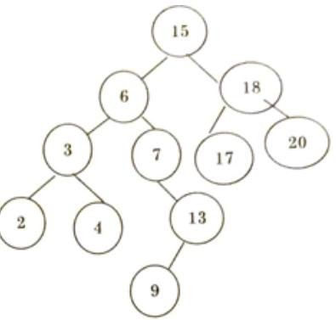
ANS:
INORDER: 2,3,4,6,7,9,13,15,17,18,20
PREORDER: 15,6,3,2,4,7,13,9,18,17,20
POSTORDER: 2,4,3,9,13,7,6,17,20,18,15 Question No 7
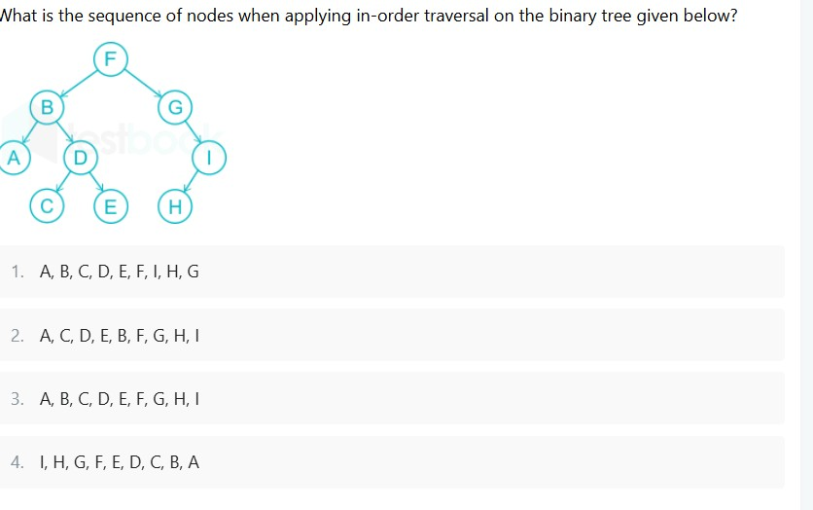
ANS: OPTION 3: A,B,C,D,E,F,G,H,I

Question No 8
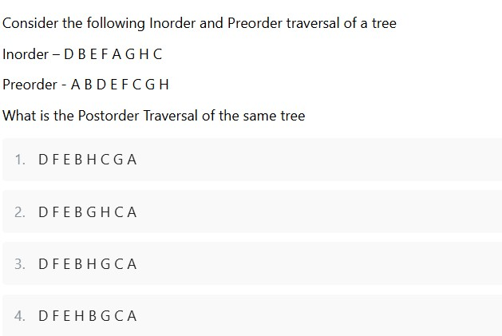
ANS : OPTION 2. D,F,E,B,G,H,C,A
Question No 9: Find Inorder, Preorder and Postorder
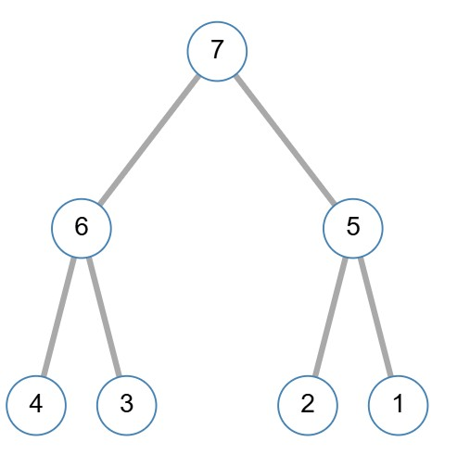
ANS:
INORDER: 4,6,3,7,2,5,1
PREORDER: 7,6,4,3,5,2,1
POSTORDER: 4,3,6,2,1,5,7
Question No 10
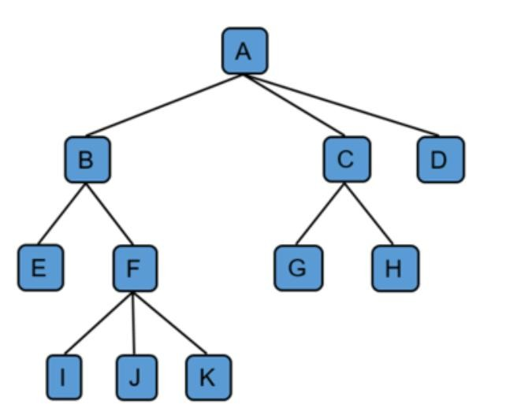
ANS:
PREORDER: A,B,E,F,I,J,K,C,G,H,D
POSTORDER: E,I,J,K,F,B,G,H,C,D,A
LEVEL ORDER: A,B,C,D,E,F,G,H,I,J,K

